1 Need to have a page the only annual subscribers have access to in their dashboard

Page will be called “Free Marketing Material”

I will have hundred of social media posts and editable guides they can use as a benefit of having an annual subscription

* We can integrate a pdf editor?
* Canva?

2 Can subscribers link their social media accounts to post directly from the dashboard

3 MORTGAGE CALCULATOR (needs to be optional for subscriber if they want to use)

* Can subscriber be notified by who used their mortgage calculator
* Can you convert an excel calculator to a web based form calculator like the mortgage calculator

4 Subscriber Text/Email/Call – CRM

* In the crm, can the subscriber click on a contact to email or text and open the messages app or email app
* Subscriber needs to be able to create custom questions in the CRM for answers
* Subscribers need to be able to export their CRM in some sort of XLS or CSV format
* Subscriber needs to receive email (and push notification when app is done) when CRM action is taken (need option to turn off crm and turn off notifications)

5 QR Code

* Need to be able to customize qr code
* How many qr codes can they create?
  + Analytics on each QR code
  + Name each qr code to keep track
  + Analytics on NFC device taps

6 Icons

* All icons seem to just have a link but they don’t all have the same functionality
* Contact card needs to have all the information to save in phone
* Social media links need to only require the username of the social media account
* Icons for custom links need to be editable (I see the option but it does not look like it works)

7 VCARD

* MAXIMUM 2 CARDS – or people will make more for other people
* Color selection does not work
* Need to be able change the order of the icons
* URL for profile must be subscriber’s username and cannot change (so much setup a username without duplication at signup

8 – FORMS

* Can we add web forms for subscribers to have their customers fill out
* Examples:
  + Credit authorization form
  + Verification of employment authorization form.
  + Can subscriber’s customers esign?

**1/15/2022**

1 – Text Message icon is not iphone text message and does not open text app

– needs to open text app for android also

2 - Need to understand how to create admin, I do not see an email address under add admin

3 - Facetime is not a link it is a phone number – needs to open facetime app

4 - Need to know how share contents work

5 - Admin>Cards>name> edit does not work

6 - Need additional smtp emails to go out (when connect received, etc)

7 - Contact card icon does not work – it is not a link. It should download all the information published on the subscribers profile

8 - Edit Card from Admin user does not work

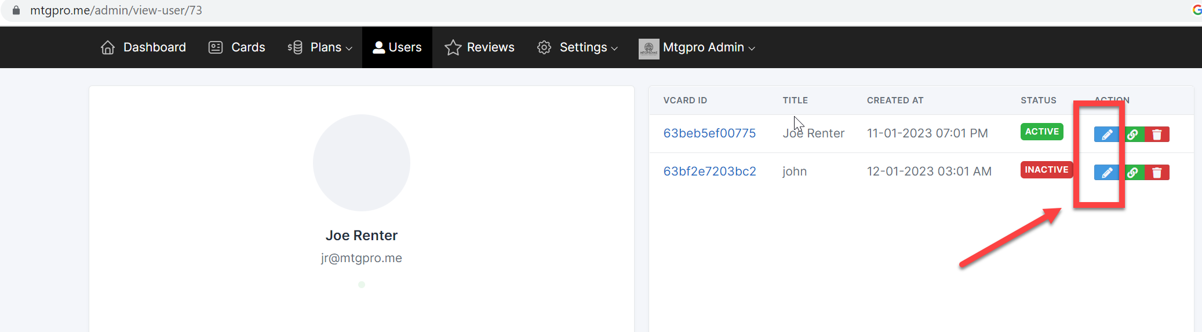

>>>>>

See below for redirect

>>>>>

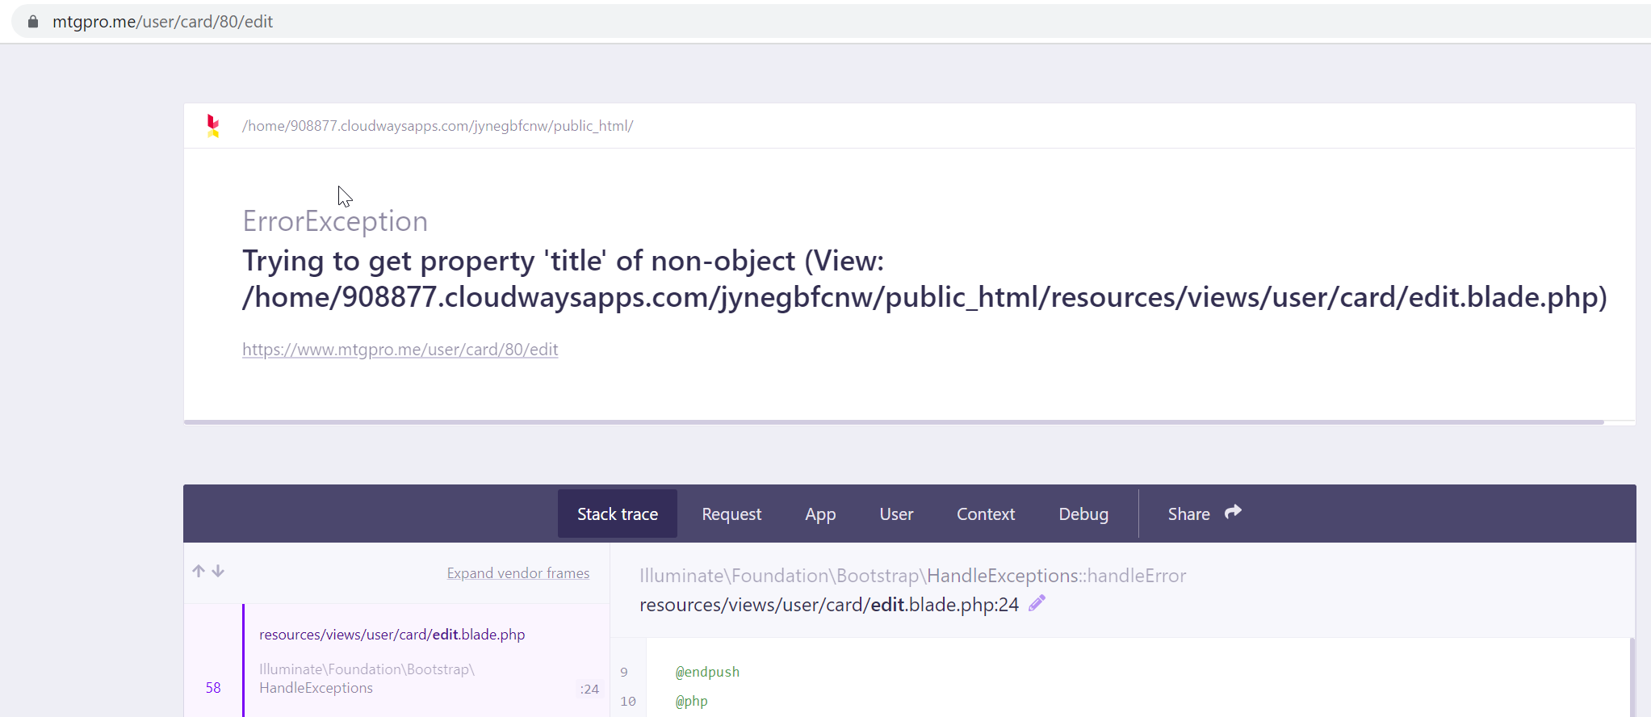

9 - What is letsconnect.site account.

From data deletion instructions?

10 - I think color scheme needs edit. This color scheme shows all icons like this and cannot see what icon is what

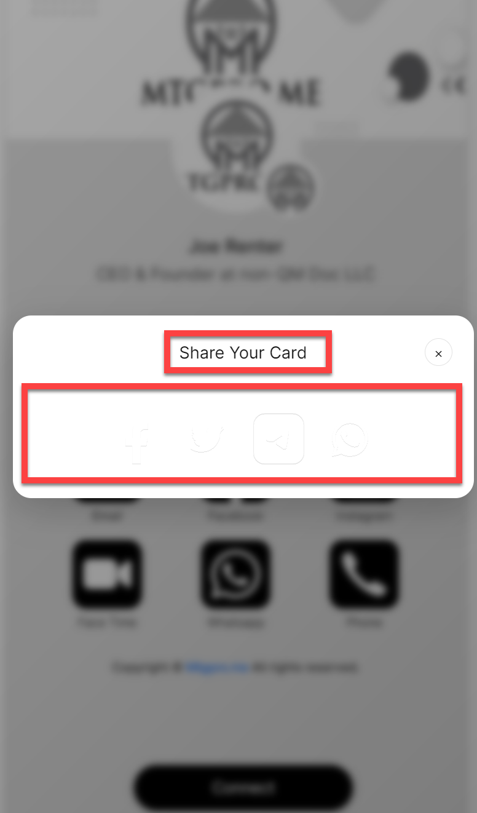

11 - CONNECT BUTTON IN PROFILE

– user profile setup they need the ability to make this required (if they want) to be done before any buttons are clicked.

Only requires fields to hit connect should be name, email and phone.

Phone text should read cell phone

“Connect” button should read, “CONNECT WITH ME”

Job Title to be called “Job Title (Optional)”

Company to be called “Company (Optional)”

“Notes on this interaction” should read “Questions, Comments or Important Details”

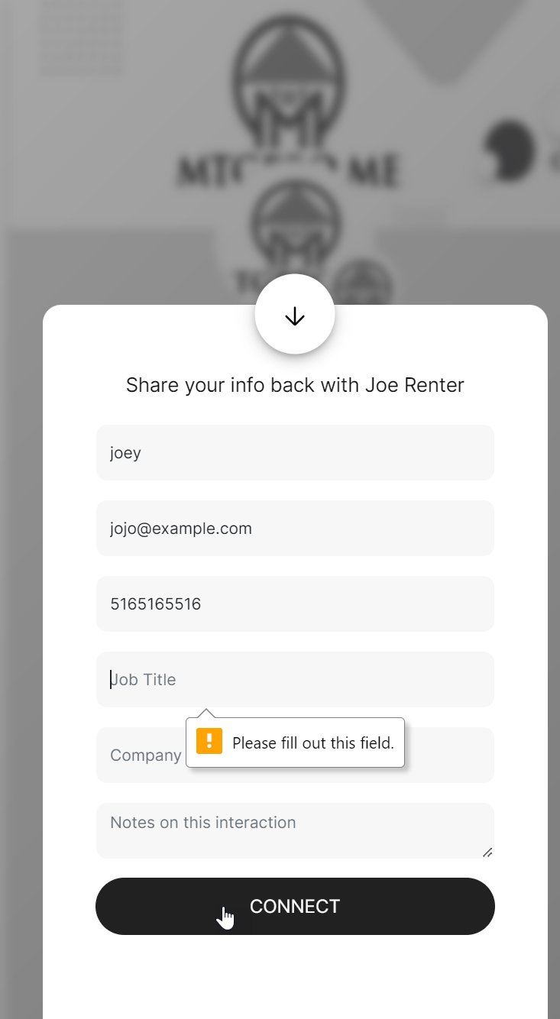

12 - Relocate renamed connect button and explain share button

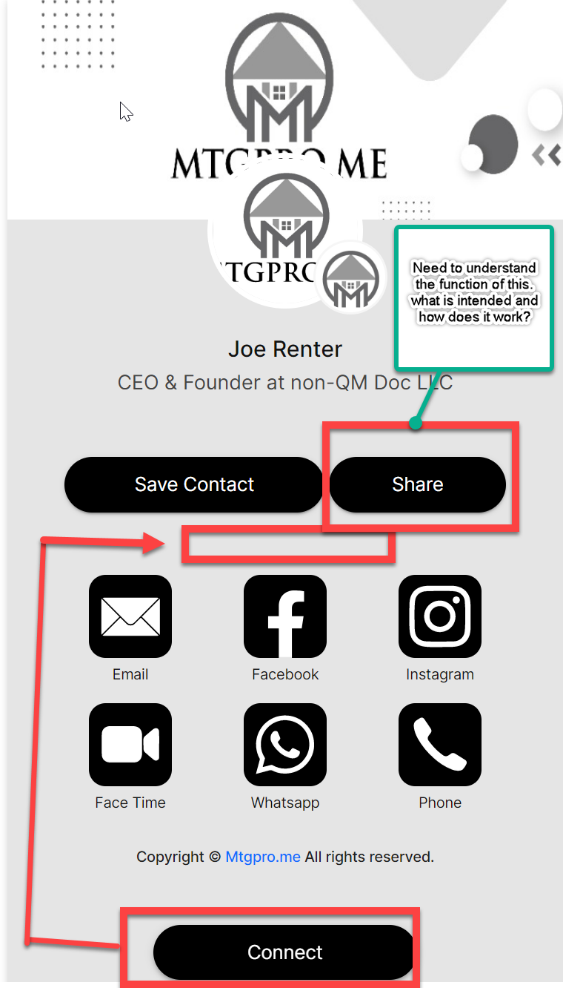

13 - <https://www.mtgpro.me/user_73>

not all icons are showing in the card and time is off

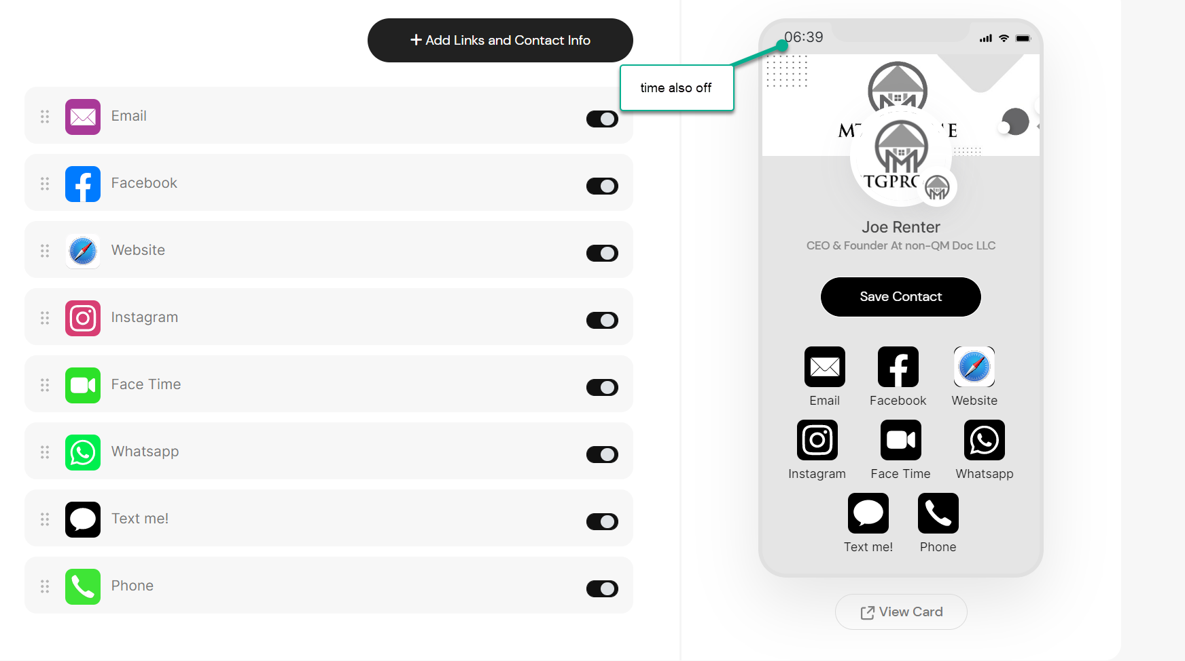

14 – QR Codes

* How do subscribers generate their QR Codes and see them?

<https://open.spotify.com/https:/open.spotify.com>(please keep main link empty)

Facetime

Embade video

<https://cash.app/$arifurrahmansw>

Address (change type text to address)

<https://www.paypal.mehttps//www.paypal.com/paypalme/>(please keep main link empty)

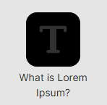Text

Zelle (number)

WeChat

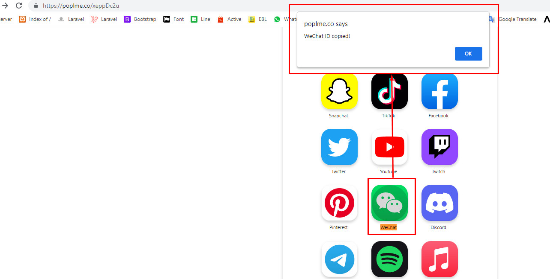

https://www.tiktok.com/404?fromUrl=/arifurrahmansw

Icon orderby not working.

Icon Edit mode show full link.